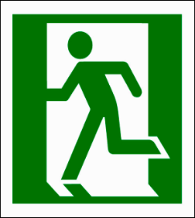




IN CASE OF
EMERGENCY

FOLLOW ADVICE FROM A WARDEN OR
LEAVE IMMEDIATELY THROUGH THE NEAREST SAFE EXIT

EXIT

GO TO THE ASSEMBLY AREA LOCATED AT:

