TASMANIA FIRE SERVICE PERMIT NO ISSUED: ….…....…
BURNING PLAN
A PERMIT HOLDERS DETAILS
Given Name: Surname:
Street/Road Number/Name:
Suburb/Town/Location:
Postcode: State: TAS Contact Phone No/s:
B LOCATION OF PLANNED BURN
Is the location of planned fire same as on permit holders details? Yes / No (If No complete details below)
Street/Road Number/Name:
Suburb/Town/Location:
or
Map Sheet Name: Scale: Grid Reference:
C DESCRIPTION OF AREA
Vegetation Type/s: Bush Scrub Grass Slash Logheaps
Years Since Last Burn: Size of Area to be Burnt (Ha):
Quantity of fine fuels (t/ha) ____________________
Topography – Predominant Aspects: North East South West
– Predominant Slope: Flat Undulating Moderate Steep
Boundaries/Control Lines: Roads Tracks Raked Lines
Stream/Water Course Green Crop Cleared/Ploughed Ground Recent Burnt Area
What needs to be done to ensure Control Lines are secure:

What is the most vulnerable edge:
D WEATHER
Temperature should not exceed 20º. Relative humidity should be above 40%.
Wind speed must be less than 15kph. Wind direction must not be from:
Nearest Fire Weather Station_________________________ Forecast Fire Danger Rating (Day of Burn)
Next Three Days | Day 1 | Day 2 | Day 3
Fire Danger Rating

E PERSONNEL and RESOURCES
Number of personnel to be on site:
Name of person in charge:
Firefighting equipment on site:

Firefighting equipment available at short notice:

F LIGHTING TECHNIQUE
How many people will be physically lighting fire:
How long will it take to light fire:
What is the most suitable time of day to light fire:
How long will the fire burn for:
Describe the sequence of lighting: (For example southern boundary 1st, once secure spot lighting down slope/upwind etc.):

G PATROL / MOP UP / EXTINGUISH
Number of personnel available to patrol and extinguish perimeter and hot spots within 100 metres of perimeter over the next three days:
What firefighting equipment will be available for this purpose:

H RISKS
Identify any assets which may be at risk as a result of the planned burn:

I ESCAPES
If the fire escapes or the fire activity is such it appears likely to escape, list your actions:

J PERMIT HOLDER’S OBLIGATIONS
This plan forms the primary conditions of your fire permit, it is not valid until approved by the Fire Permit Officer and has the permit number written in the top right hand corner of the front page. This plan must be retained by you and you must be able to produce this plan and your fire permit upon the request of an authorised officer at any time during the duration of the fire. Failure to retain this plan will be deemed to be a breach of the conditions of permit. A copy of the plan must be provided for the permit officer.
Upon the declaration of a Total Fire Ban your permit is revoked. If your fire is alight you must take immediate steps to stop it spreading and extinguish it.
If you need help dial 000 and ask for the Fire Service
K ADDITIONAL INFORMATION
FIRE WEATHER INFORMATION
Listed below are the Fire Weather Forecast Station for which the Bureau of Meteorology issues detailed fire weather forecasts and fire weather outlooks. The information for the fire weather station nearest the planned burn area is available from a number of sources.
Weather by Fax (Bureau of Meteorology) and which can be accessed by Fax Machine
Fire Weather Forecast for next day/or on the day of the planned burn Phone: 1902 935 803
Fire Weather Outlook for the next three days Phone: 1902 935 804
Bureau of Meteorology Ph: (03)62212000 and ask for the Fire Danger Rating for a specific station.
State Fire Management Council Web Site http://www.sfmc.tas.gov.au/part_a/intro_weather_map.htm and follow the link to Fire Danger Index Forecasts and outlooks.
Fire Weather Forecast Stations
Bushy Park, Devonport, Dover, Fingal, Flinders Is Airport, Friendly Beaches, Geeveston, Hobart Airport, Hobart City, King Is Airport, Launceston Airport, Launceston City, Liawenee, Luncheon Hill, Marrawah, Maydena, Moogara, Mt Wellington, Ouse, Palmers Lookout, Scotts Peak, Scottsdale, Smithton, St Helens, Strahan Airport, Tarraleah, Tunnack.
EXAMPLE OF PLAN OF BURNING AREA AND LIGHTING TECHNIQUE
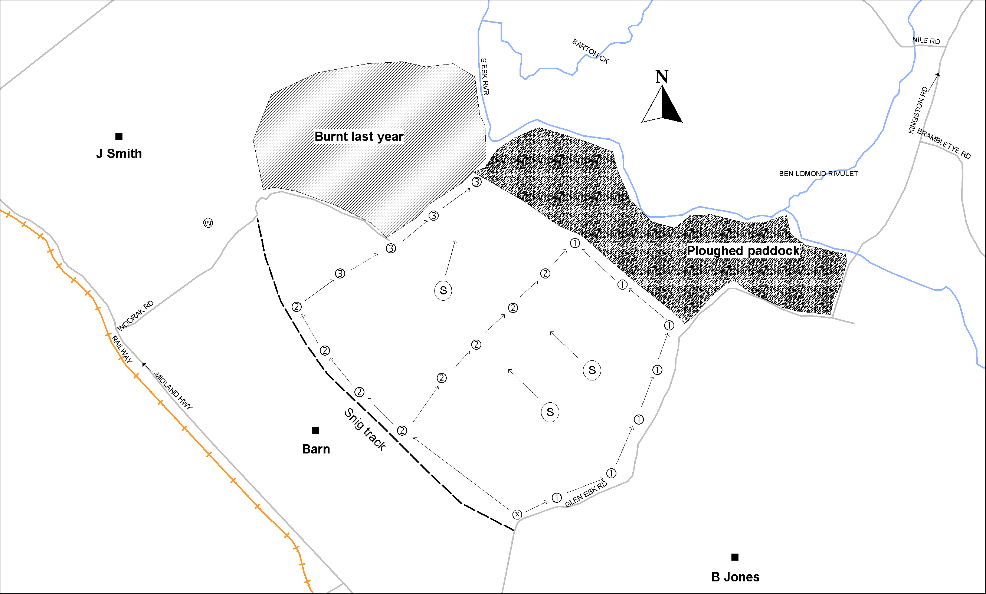

LEGEND FOR BURNING PLAN
Sighting sequence & direction S
Tighting sequence & direction S
Xighting sequence & direction S
Wghting sequence & direction S
Water Point | Road
Start Point | Track
→ Down Slope | Control Line
Tanker | Stream/Creek
■ Assets/Neighbours | ①→①→ Lighting sequence & direction
 | ②→②→ Lighting sequence & direction

PLAN OF APPLICANTS BURNING AREA AND LIGHTING TECHNIQUE



Scale

SYMBOLS FOR BURNING PLAN

Water Point  Sighting sequence & direction S  Tighting sequence & direction S  Xighting sequence & direction S  Wghting sequence & direction S | Road
Start Point | Track
→ Down Slope | Control Line
Tanker | Stream/Creek
■ Assets/Neighbours | ①→①→ Lighting sequence & direction
 | ②→②→ Lighting sequence & direction

This Plan Approved By: (PRINT) (SIGNATURE)
Position: …………………………………….………………………………..Date: …..../….../…...

