In case of emergency DO THIS

EVACUATION |  | FIRE
On being given a signal to Evacuate…  - Follow instructions as directed by a Warden or through the building communication system.  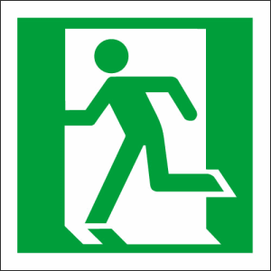  - Leave the building via the nearest safe exit:  EXIT  - Proceed to the assembly area and remain there until otherwise advised by a warden or fire officer. |  | - Assist any person in immediate danger ONLY if safe to do so.  - Close the door.  - Call the Fire Brigade on 000.  - Attempt to extinguish fire ONLY if safe to do so.  - Evacuate to assembly area.  - Remain at assembly area until you are accounted for.

Your nearest assembly area is:

