IN CASE OF
EMERGENCY

FOLLOW ADVICE FROM A WARDEN

OR

LEAVE IMMEDIATELY THROUGH THE NEAREST SAFE EXIT

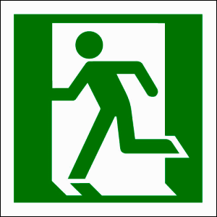
EXIT OR

GO TO THE ASSEMBLY AREA LOCATED AT:

________________________________________________

